**Level 1: PC Tower Case**

**Outline**

Learn about the internals of a standard PC case by examining physical samples and selecting and labeling images found on-line. Gain deeper knowledge by researching and reporting on specific components.

**Questions**

1. 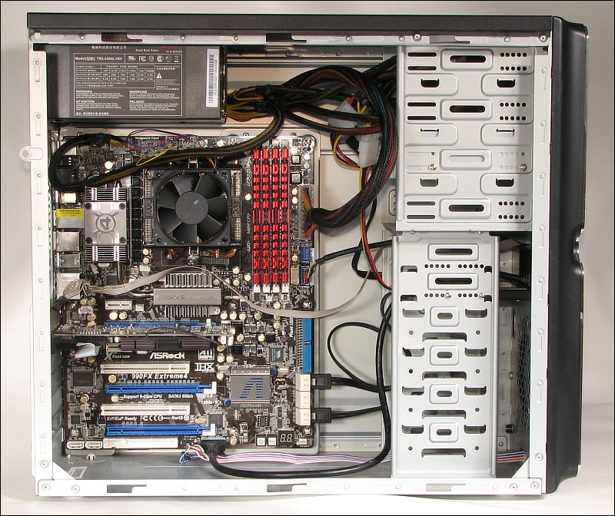Find one (or more) images that clearly show the internals of a PC Tower Case.

Hard Disk Drive

Optical Disk Drive

Cooling Fan

Power supply

Motherboard

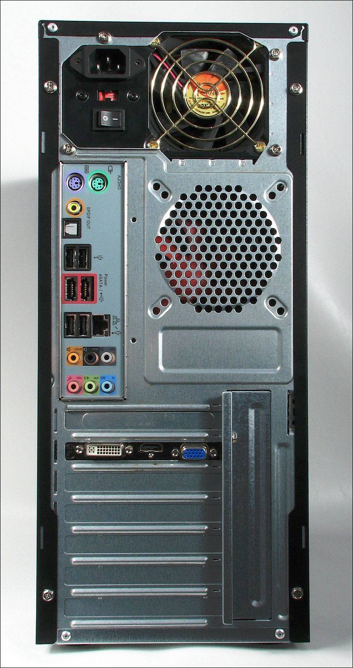

Power in

Smps Fan

Usb Ports

Lan Port

Audio Ports

DVI Port

HDMI Port

VGA Port

1. Clearly label the following components (using arrows) on your image of the PC case internals:
   1. Motherboard
   2. Power Supply
   3. Hard Disk Drive
   4. Optical Disk Drive (e.g.DVD)
   5. USB Expansion Ports
   6. Monitor Port
   7. Audio Ports
   8. Ethernet Port
   9. Cooling Fan
2. Research more in-depth about “Motherboards”. Make notes on the following:
   1. What different versions are currently available (speed and capacity)
   2. How the component has changed since the 1980’s

There are 4 types of Motherboards. XT motherboards (eXtended technology motherboards) are old model motherboards, in this mother board there are old processor sockets LIF, Ram Slots Dimm and ISA, 12pin power connector and no ports. There are AT motherboards (Advanced technology), in these there are PGA sockets, SD ram slots, 20 pin power connector PCI slots and ISA slots. Baby At motherboards are combinations of XT and AT, these motherboards contain both slot type processor sockets and PGA processor sockets, SD ram slots, DDR ram slots, PCI slots and ISA slots, 12 pin connector and 20 pin connector and ports. ATX motherboards (Advance technology eXtended), these motherboards contain MPGA processor sockets, DDR, AGP and PCI slots, SATA connectors 20 pin and 24 pin power connector and ports. The motherboards have changed significantly since the 1980s, the motherboards have upgraded, most motherboards now use SATA, ISA was fully replaced by PCI and PCIe, the processors we have now are much better in terms of processing power, there are also many more features like secure boot and more. Also now we have more computers using UEFI rather than Bios. In general, our motherboards we have are at least 5x better than what we had before and will continue to get better.

<https://www.hardwarezone.com.sg/m/feature-hardwarezones-10th-anniversary-special/motherboard-evolution-decade>

https://www.slideshare.net/sivagnanamuthu/four-types-of-motherboards

1. Research more in-depth about “Hard Disk Drives”. Make notes on the following:
   1. What different versions are currently available (speed and capacity)
   2. How the component has changed since the 1980’s

As of now you can get hard disk drives, SATA drives (Serial Advanced Technology Attachment), PATA (Parallel Advanced Technology Attachment), SCSI (Small Computer System Interface) and SSD’s (solid state drives). The fastest and least likely to break down drive is the SSD, since it contains no moving parts, it will be faster and has less of a chance to break down. In the 1980s there were 10mb to 1gb sized hard drives, they were not that fast, and were extremely expensive but now our hard drives go from 500gb to 2tb and more, our hard drives are also extremely fast you access data in less than 5 seconds, and they are affordable ranging from $50 to $500 depending on the amount of space and type of hard drive.

**Level 2: PC Motherboard**

**Outline**

Learn about the structure of a standard PC motherboard by examining physical samples and selecting and labeling images found on-line. Gain deeper knowledge by researching and reporting on specific components.

**Questions**

1. 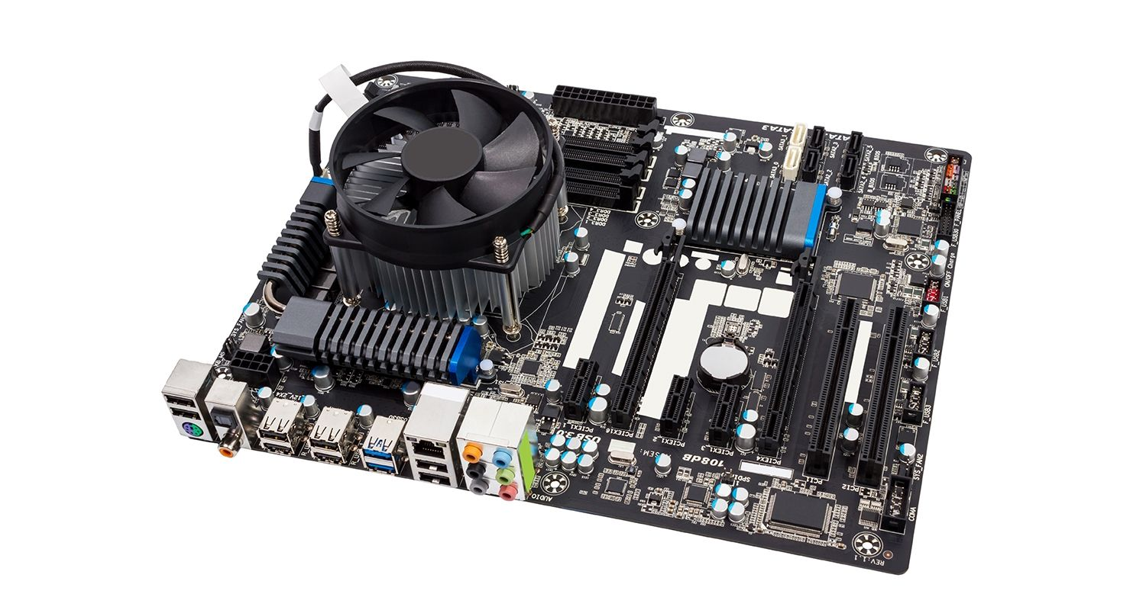Find one (or more) images that clearly show the layout of a PC Motherboard.   
   (i.e. Google images using keywords “PC Motherboard”)

Sound processor, Can be built in or put into expansion slot

Gpu Goes into the slots, and sometimes computers have it built in

RAM

Wi-Fi card (Usually goes in expansion slot)

SATA

CPU Fan and CPU (CPU is under the fan)

1. Clearly label the following components (using arrows) on your image of the PC motherboard:
   1. CPU (and fan)
   2. RAM Memory
   3. Disk Drive Interface (IDE or SATA)
   4. GPU Graphics Processor (either on-board or Graphics Card)
   5. Sound Processor (either on-board or Sound Card)
   6. Wi-Fi / Ethernet Network Interface (either on-board or Graphics Card)

1. Research more in-depth about “CPU Processor Chip”. Make notes on the following:
   1. What different versions are currently available (speed and capacity)
   2. How the component has changed since the 1980’s

The two main manufacturers are Intel and AMD (Advanced micro devices), both processors manufacturers are almost equally good with slight difference which is AMD processors will be better for tasks like gaming, recording and 3D rendering. CPU speeds are measured in GHz (gigahertz) which is a unit of measurement for AC or EM wave frequencies. In the 1980s, processors were quite slow and were still in the development process, over the years the processors speed have become extremely fast (especially new ones) and now manufacturers are competing to make the fastest and most efficient processor.

1. Research more in-depth about “RAM Memory”. Make notes on the following:
   1. What different versions are currently available (speed and capacity)
   2. How the component has changed since the 1980’s

RAM (Random access memory) is the virtual space that computers use to manage information and solve problems. The main types of RAM memory you can get today are Flash memory, which was released in 1984 and is used until today. Flash memory retains all data after power has been cut off and is most commonly used in USB’s, printers, memory cards, PDA’s and etc. Static RAM (SRAM), which was released in the 1990s and is still used today. SRAM requires a constant flow of power to function, because of this refreshing is not needed to keep data intact and it also deletes all the data that has been stored once power is cut off. SRAM is used in digital cameras, routers, CPU cache, digital to analog convertors and etc. Dynamic RAM (DRAM), which was released in 1970s and was used up to the mid-90s. DRAM requires reoccurring refreshes of power so it can function, refreshing is needed to keep data intact. Once power is lost all stored data is also lost. DRAM is used in video game consoles, networking hardware, video graphics memory, system memory and etc. Some significant changes for the component included the creation of SDRAM (Synchronous Dynamic RAM) in 1993, which lead to the discovery of pipelining – “the ability to receive (read) a new instruction before the previous instruction has been fully resolved (write)”. This led to higher CPU transfer/performance rates. Another significant change to this component over the years was the creation of the Double Data Rate Synchronous Dynamic RAM (DDR SDRAM), which basically doubled the performance rates of the SDRAM. It can read two and write two instruction every clock cycle which is basically double the SDRAM.  
  
https://www.lifewire.com/types-of-ram-4150713

**Level 3: Peripheral Devices**

**Outline**

Learn about how peripheral devices are connected to the back side of a typical PC tower case. Examine physical samples, select and labeling images found on-line and gain deeper knowledge by researching and reporting on specific components.

**Questions**

1. 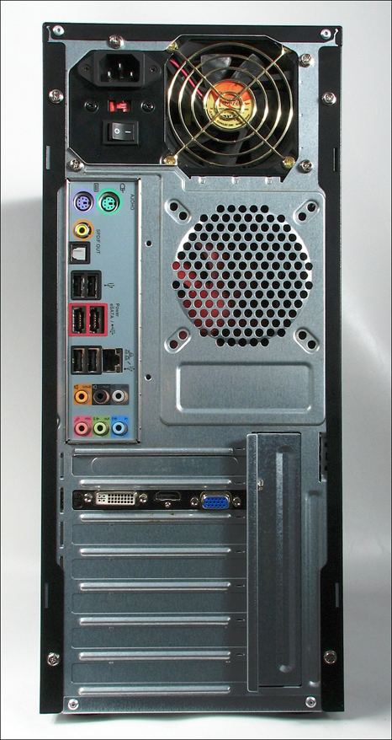Find one (or more) images that clearly show the layout of the back of a typical PC tower case.   
   (i.e. Google images using keywords “Back Of PC Tower”)

Ethernet interface

Audio inputs and outputs

USB ports

PS/2 or USB ports for mouse

Ps/2 or USB ports for keyboard

Power cord and power switch

Monitor interface

1. Clearly label the following components (using arrows) on your image of the back of a typical PC tower case:
   1. Power cord and power switch
   2. Monitor Interface (VGA or DVI or HDMI)
   3. Mouse Interface (USB or PS/2)
   4. Keyboard Interface (USB or PS/2)
   5. USB Ports
   6. Audio Inputs / Outputs
   7. Ethernet Interface

1. Research more in-depth about “Monitor Technology”. Make notes on the following:
   1. What different versions are currently available (e.g. VGA / DVI, Flat Panel Technology))
   2. How the component has changed since the 1980’s (e.g. Display Resolution, Technology)

The main types of monitor technologies are CRT (Cathode ray tubes), in this a stream of intense high energy electrons are used to forms images on a fluorescent screen. CRT monitors are being used less and less because of their weight and repair costs. LCD (Liquid crystal display), in this an optical effect is made by polarizing the light in varied amounts and making it pass through the liquid crystal layer. There are two types of LCD technologies, an active matrix of TFT and a passive matrix. TFT generates better quality and is more secure while passive matrix has a slow response time. These monitors and light and can run off batteries making them great for laptops. LED (Light emitting diodes) technology, this technology is the same as LCD but is flat paneled and uses light emitting diodes for back-lighting to produces images. LED monitors produce images with higher contrast, use less power, compact, and they don’t produce much heat when running. The only problem is they can be expensive. There are also different ways to connect these monitors like using HDMI (High definition multimedia interface) which is used for transmitting uncompressed video data and compressed or uncompressed audio data from device to device, DVI (digital visual interface), it is designed to transmit uncompressed video from device to device, VGA (Video graphics array), which carries analog components RGBHV video signals and VESA DDC data from device to device. In the 1980’s most monitors used CRT monitors, which were heavy, bulky, expensive to repair and the picture quality was not the best. These monitors are now outdated and is only rarely used, most people mainly use LED monitors now since they are lightweight, flat paneled, use less power and produce high quality images. Also, to connect monitors to the pc, VGA, DVI and HDMI are still used, HDMI and VGA are more common than DVI.

https://www.techadvisory.org/2014/09/types-of-computer-monitors/

1. Research more in-depth about “External Portable Storage”. Make notes on the following:
   1. Floppy Disks

Floppy Disks were developed around the 1960’s and are a “type of disk storage composed of a disk of thin and flexible magnetic storage medium, sealed in a rectangular plastic enclosure lined with fabric that removes dust particles”. They are written and read by a floppy disk drive, they are not used much now. These drives would fit into the rectangular boxes at the front of the pc.

https://en.wikipedia.org/wiki/Floppy_disk

* 1. CD-ROM / DVD / Recordable CD/DVD

CD-ROM (Compact disk read only memory) are CD’s that can be read by a computer with an optical drive. DVDs (digital versatile disc) where used to store any kind of digital data and it offers more storage than compact disks. Some DVDs are produced using “molding machines that physically stamp data onto the DVD”, these DVDs can only be read. While blank recordable DVD discs can be recorded once using a DVD recorded and Rewritable DDVDs can be recorded and erased many times.

https://en.wikipedia.org/wiki/DVD

* 1. USB Memory Drives

USB flash drives are portable data storage devices that include flash memory. They can be written/erased up to 100,000 times (high end USB’s). They range from 8gb to 2tb’s and are mainly used for storage, data transfer, data backup and etc. They are faster than CD’s and are smaller.

https://en.wikipedia.org/wiki/USB_flash_drive

* 1. Compact Flash Memory

Compact flash (CF) are flash memory storage devices and were mainly used in portable electronics like cameras and handheld gaming devices due to their size and incredibly large storage. Many devices up to this day still use these cards and they can store data anywhere from 2mb to 512gb.

https://en.wikipedia.org/wiki/CompactFlash

* 1. Cloud Based Storage

Cloud storage is basically storage online, where you can store all your data online of the hosting companies servers. The company is responsible for keeping the data available and accessible. Most cloud storages require subscription for more storage. Cloud storages are more commonly used now since you can access your data anywhere. Some examples are google drive, one drive and dropbox.

**Level 4: PC Component Presentation**

**Outline**

Explore the development and features of a specific PC hardware component through deeper research and investigation. Work in partners to create a short presentation. Deliver the presentation to the class.

Each group will research a unique PC hardware component . Your specific topic will be assigned from the list provided below.

**Presentation Structure**

1. Explain what the PC component does and how it fits together with other components to make up a fully functioning PC.
2. Explain how the PC component works. Provide a diagram (image) showing the main parts of the component.
3. Research the current state of the art of the component in terms speed, capacity (size), and other related factors.
4. Research on-line suppliers that sell the PC Component. List the specifications for the available products and the cost (price).
5. Research how the PC component has changed and evolved since the early days of PCs in the 1980’s. Cover each of the following topics separately:
   1. Component Speed
   2. Component Size / Capacity
   3. Two other specifications specific to the PC component (ask Mr. Nestor)

**PC Component Topics**

|  |  |  |
| --- | --- | --- |
| **Topic** | **Partner 1** | **Partner 2** |
| CPU Microprocessor Chip |  |  |
| Motherboard Layout |  |  |
| Computer Graphics |  |  |
| Sound & Audio |  |  |
| Hard Disk Drives |  |  |
| Removable Disk Storage |  |  |
| Network / Internet Connectivity |  |  |
| Mouse / Pointing Devices |  |  |
| Monitor & Display Technology |  |  |
| Printers & Output Technology |  |  |